The New York Nitrogen Removal Programs

New York has three water quality based nitrogen removal programs as follows:

The Long Island Sound Total Maximum Daily Load TMDL for New York requires a 58.5% reduction in total nitrogen discharged into Long Island Sound.

Figure 1. Long Island Sound hypoxic conditions frequency years 1991-2008

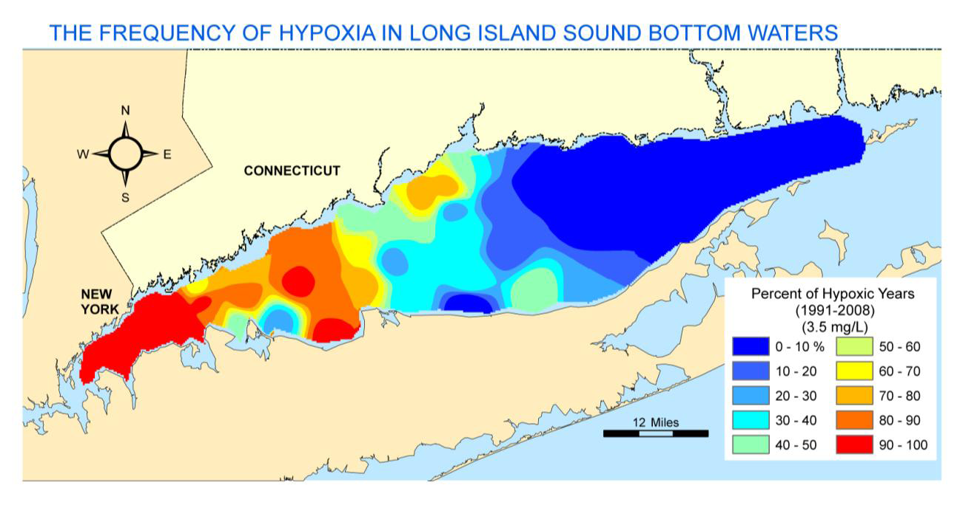

The TMDL for Long Island Sound includes 7 of New York City’s 14 POTWs, 4 Westchester County POTWs and 8 POTWs that are located on the north shore of Long Island. The New York portion of the TMDL for Long Island Sound requires a 58.5% reduction in total nitrogen discharged by January 1, 2017.
The NPDES permits for total nitrogen discharging into Long Island Sound are written as mass based 12 month rolling average permits. The permits use several step milestones to reach the final TMDL limit of a 58.5% reduction.
New York City was given a combined bubble nitrogen load for all 7 POTWs in the TMDL and this allowed for BNR facilities to be constructed at 4 POTWs (Bowery Bay, Hunts Point, Tallman Island and Wards Island to meet the TMDL. Presently Hunts Point is now in full operation using 70% glycerol solution as a supplemental carbon source. Partial centrate sludge treatment is also in use at Wards Island. The Wards Island facility uses the SHARRON process for high strength waste that formally used methanol as the supplemental carbon source. The process was changed over to 70% glycerol in July 2014 as part of the New York City BNR plan to use only non-flammable carbon sources.
Westchester County operates 4 POTWs and like New York City was allowed to use the same combined mass based load. The 58.5% total nitrogen reduction is being achieved at the Mamaroneck and New Rochelle POTWs. Both facilities are in operation and use a 25% dilute methanol solution.

North Shore Long Island facilities have individual permits and are achieving the TMDL limit with technologies that do not require a supplemental carbon source. Most of these facilities are relatively small and have extra reserve flow capacity.

Jamaica Bay Nitrogen Reduction Program
The Jamaica Bay Nitrogen Reduction Program is a water quality performance based permit program that includes two New York City POTWs, Jamaica WPCP and the 26th Ward WPCP that discharge into Jamaica Bay. Both facilities are being upgraded to use 70% glycerol as a supplemental carbon source and will be in full operation by January 2017 satisfying the permit requirements.

Chesapeake Bay TMDL
There are 10 NPDES major (over 1 mgd) POTWs that discharge into the Susquehanna River basin that flows into Chesapeake Bay. The limits for the POTWs are required by 2017 and final TMDL compliance by 2025. Within the next 5 years only the largest POTW the 60 million mgd Binghamton- Johnson POTW will require supplemental use carbon by 2017.

