The Connecticut Nitrogen Removal Program as part of the Long Island Sound Total Maximum Daily Load TMDL

The most significant water quality problem to Long Island Sound (LIS) is caused by over enrichment of nutrients, specifically nitrogen that leads to greatly reduced levels of dissolved oxygen in the bottom waters of western LIS. The overload of nitrogen fuels excessive growth of algae which eventually dies, sinks to the bottom and decays. During decay, oxygen is consumed and falls to levels well below those allowable in state water quality standards. Primary sources of nitrogen include municipal wastewater treatment plant discharges (see figure 1).

Figure 1. Long Island Sound hypoxic conditions frequency years 1991-2008

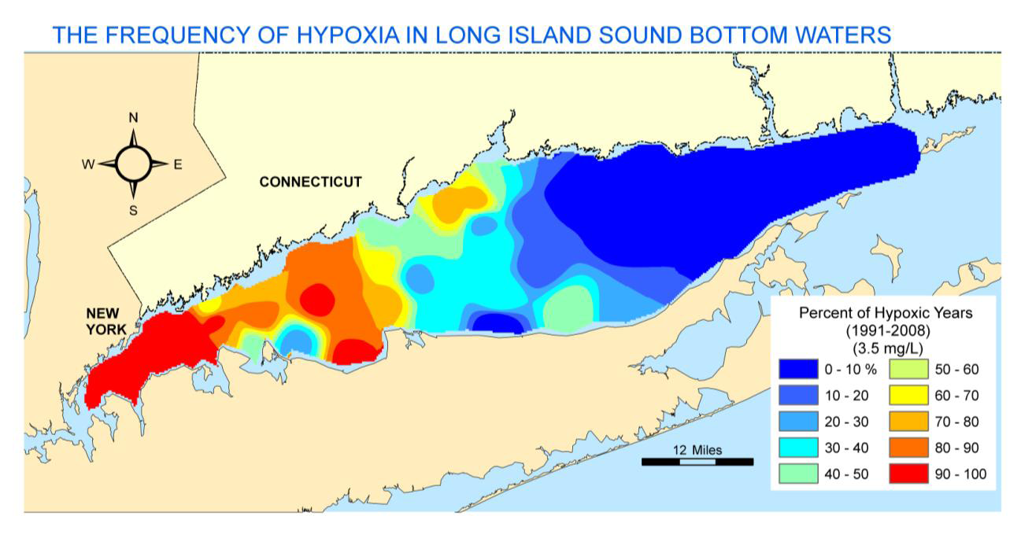

In April 2001, the US EPA approved Connecticut and New York’s jointly submitted TMDL to address the impairment to LIS water quality that results from excessive nitrogen loading. In this TMDL, discharges from publicly owned treatment works (POTWs) were targeted for control. A 58.5 percent reduction was set for 79 Connecticut POTWs by 2014 through a waste load allocation process.

As the result of the TMDL and waste load allocation significant permit changes effecting total nitrogen limits to individual POTWs were required. In order to mitigate the financial burden of upgrading 79 Connecticut POTWs to low level nitrogen treatment processes a nitrogen trading program was established more than a decade ago. The nitrogen trading program was developed with a general permit for nitrogen discharges that provides annual mass nitrogen limits for the 79 publically owned treatment works (POTWs) covered in the waste load allocation. The permit has annual mass discharge limits in pounds of total nitrogen discharged for each discharger. If a discharger reduces total nitrogen below the limit then they may sell the excess credits. Conversely, a discharger that is above the limit must purchase credits. The general permit is reissued on a five year bases, the next renewal is scheduled for 2015 with the limits now reduced to the final TMDL 58.5% reduction required. In the future the TMDL requires that nitrogen reductions be maintain at the current 2014 load of nitrogen discharged into the future.

The program is managed by the Connecticut Department of Energy and Environmental Protection (DEEP) along with an appointed Nitrogen Credit Advisory Board (NCAB). The DEEP and NCAB are required to issue reports annually to the Connecticut General Assemble outlining the success of the program along with a full accounting of monies exchanged through credit purchases and sales.
To date, more than 50 nitrogen removal projects have been implemented, representing nearly 4.5 million kg (10 million lb) of nitrogen removed from the waste stream annually. Approximately 16 POTWs are using or are projected to use supplemental carbon to meet their permit requirements. The majority of these treatment facilities are located in Connecticut’s largest cities and represent the largest treatment facilities.

